Instructions to share a LinkedIn Post.

From desktop:
- Click Start a post at the top of your LinkedIn homepage to share a post.
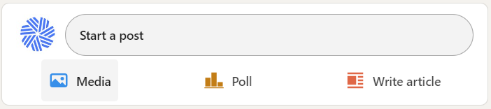
- Type the content of your post in the What do you want to talk about? field.
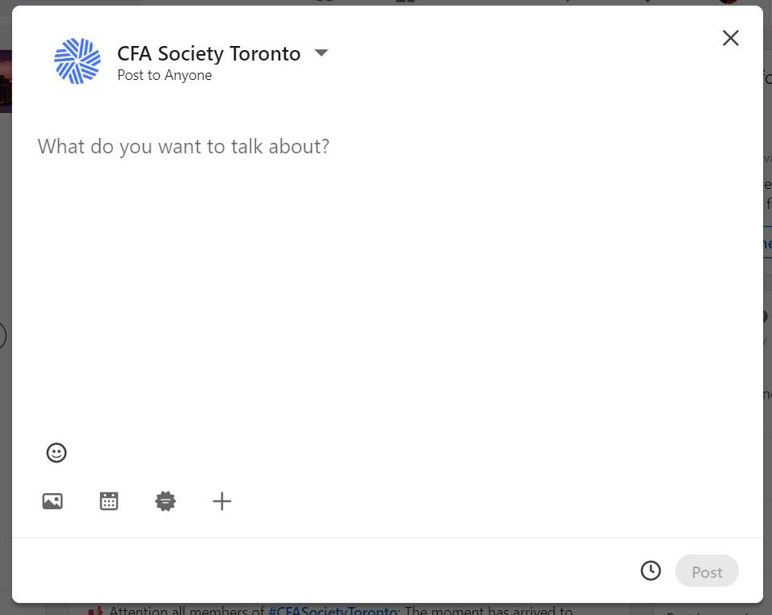
- You can add an image to your post with the image icon at the bottom left-hand side.
- Once you’ve written your message, you can then click Post at the bottom right-hand side.

Example of posts:
- I am a proud member of the #CFASocietyToronto!
- I am part of the largest CFA Society in the world! #CFASocietyToronto
- I have renewed my #CFASocietyToronto membership!

